# Apply filters to SQL queries

## Project description

My organization is working to make their system more secure. It is my job to ensure the system is safe, investigate all potential security issues, and update employee computers as needed. The following steps provide examples of how I used SQL with filters to perform security-related tasks.   
Filter with AND, OR, and NOT

## Retrieve after hours failed login attempts

The result is 19 people who failed login attempts that occurred after 18:00.

## Retrieve login attempts on specific dates

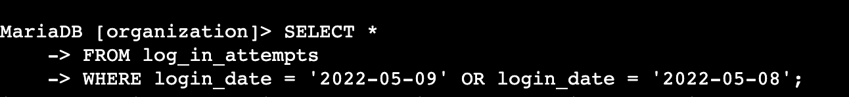There are 75 login attempts were made on these two days

## Retrieve login attempts outside of Mexico

144 login attempts were made outside of Mexico.

## Retrieve employees in Marketing

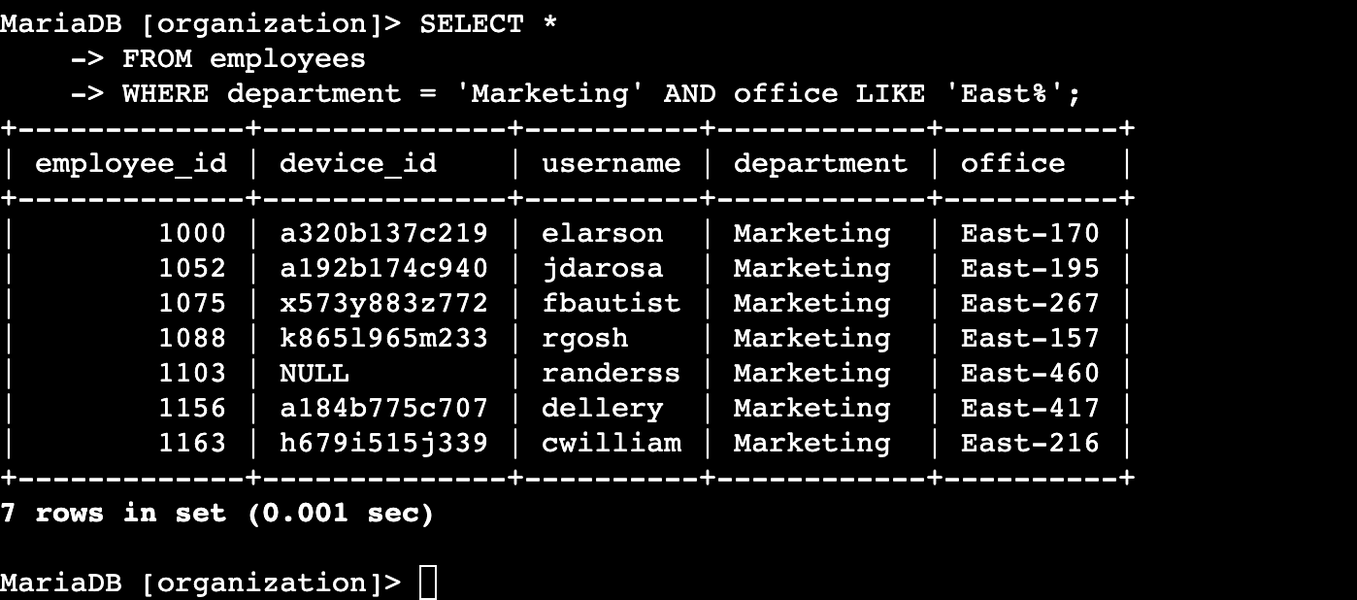There are 7 employees from the marketing department from the East’s office.

## Retrieve employees in Finance or Sales



There are 71 employees in the Sales and Finance department returned by the query.

## Retrieve all employees not in IT

There are 161 employees who are not in the Information Technology department.

## 